**May 2024**

**Child Evangelism Fellowship ®of Franklin and Fulton County**

**Impact**

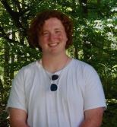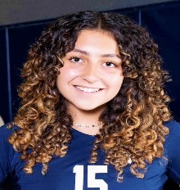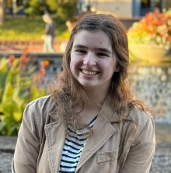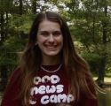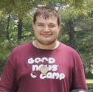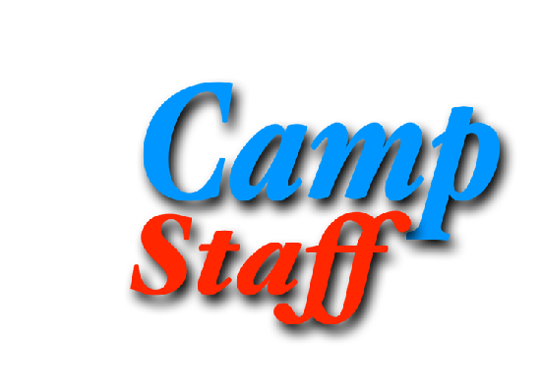

**Ryan**

**Matt**

**Jeffrey**

**Caleb**

**Abigail**

**Chloe**

**Madison**

**Colin**

**Molly**

**Ethan**

**Cassie**

**Emily**

If any of you have ever played a sport you understand the importance of teamwork. A team is not dependent on one player, but instead relies on each other bringing out the best in each other. That is what we have been praying for our summer staff. Summer will be a little different with Tiffanie and I micromanaging chemotherapy and other doctor appointments. We knew we needed a good team that would honor Christ and love the boys and girls. We are blessed to announce our summer staff. **Emily Kilcup and Molly Stouffer** will be returning as chapel leaders. **Jeffrey Yeager, Colin Donatto, and Matt Hansen** will teach a group each of the eight weeks this summer. **Caleb Schroder, Madison Seal, and Ryan Kilcup** will be returning as junior staff also. New staff this year include **Ethan Strode, Abigail Vaughn, James Smith, Cassie Turner, Rylie Baker, and Chloe Castellar.** This doesn’t include our regular staff, Nathan Egolf and Stephen Burdette.

We’re thrilled to have such experienced workers to help camp run smoothly. Since we have a new group of volunteers come to camp each week, the junior staff members provide consistency and knowledge that comes from being there multiple weeks. Each of them has committed to serve for four or more weeks. Several of them plan to be there all eight weeks of camp. They will serve as teachers, junior counselors, craft leaders, afternoon activity coordinators, or wherever else they’re needed. **Many of our junior staff will have to raise support much like a missionary. Would you consider giving to them financially? Maybe your church would like to adopt one of them as your summer missionary? Or maybe you feel led to give to them. For many of them, this will be their first experience raising support. We want them to see God provide for them! Contact the office to find out who needs support.**

Please pray for our camp staff as they serve this summer. Pray that this will be a meaningful experience in their lives and that they will be a blessing as they serve. Here are a few pictures of our summer staff.

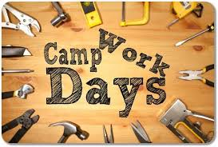

**Social Media**

Look us up at CEF® Franklin and Fulton County on Facebook. We are sharing updates, meetings, teacher tips, Unite® videos, devotions, and more.

We have also created an online platform to make giving easier. Here is the website for the online giving:  
<https://franklincef.breezechms.com/give/online>

**QR Code for Camp**

**Contact us:**

Matt and Tiffanie Robinson Coordinator and Co-Cordinator

[pastormattcef@gmail.com](mailto:pastormattcef@gmail.com)

240-625-0056

Lori Schroder - Office Manager

Nathan Egolf- Field Worker

Stephen Burdette – Field Worker

PO Box 6, Waynesboro, PA 17268

Office: (717) 762-2115

45 S Broad Street, Waynesboro, PA 17268

Email: cefoffice@franklincef.com

website: www.franklincef.com



A huge thanks to those who have purchased items off our Amazon wishlist! We have been amazed by your kindness. You can find the link on our Facebook page or you can email the office for a link to purchase items.

We have a few big needs on the horizon. One of our biggest needs will be getting the pond ready. **We will need quite a bit of sand to create our ‘beach’ again. If you would like to donate toward that project let us know.**

Camp News and Needs

**Mark your calendar for our upcoming work days at Good News Camp.** Camp is a HUGE blessing. Over 400 children have already registered and we are expecting over 1300 kids this summer. That means 1300 boys and girls will hear the Gospel. That means a lot of staff and a lot of prep to get the camp ready. We have a few work teams coming from local Christian schools but we will need a few other days to get this monumental task done. Many hands make for light labor.

Our first work day will be **May 4th, 8-12** (Possibly later). This day will focus on cleaning out the creek, clearing the levee, and taking down old dead trees. This is basically a day to move and chop wood. Chainsaws are needed. Feel free to bring other tools that day. You will also need 'waders' to clean out the levee area. Donuts will be provided. A light lunch will also be provided.

Next, **May 11th: 8-12**. This will be a day to dispose of wood, tidy up the exterior of camp, and do other random jobs. Bring tools to help get the camp ready. Donuts and lunch will be provided.

camp, and do other random jobs. Bring tools to help get the camp ready. Donuts and lunch will be provided.

Finally on **June 1st, 8-12**. This will be a quick wipe-down, clean day. We will clean the bathrooms, chapel, windows, etc. This day will consist mainly of interior work. Donuts and lunch again will be provided.

We would love to have you join us as we prep camp for a busy summer!

Can you believe that camp will be starting in a few weeks? Make sure you register your child ASAP. If you are interested in sending your child to camp please go to [www.franklincef.com](http://www.franklincef.com) or use the QR code on this letter!

We also need a few more teachers. Right now we have four weeks booked, but we still need about 20 more teachers.

**Don’t forget about our junior counselor training**. To be a counselor at camp you must have finished 8th grade, served at least one week as a helper, and attend **one** of our training meetings. The meetings will be at Good News Camp on:  
**FRIDAY MAY 3rd, 6-7 PM**

**SATURDAY MAY 18TH, 10-11 AM**

proprius. In consequat os quae nulla magna. Delenit abdo esse quia, te huic. Ratis neque ymo, venio illum pala damnum. Aptent nulla aliquip camur ut consequa.

Aptent. Adipiscing magna   
jumentum velit iriure   
obruo vel.Volutpat mos   
at neque nulla lobortis   
dignissim conventio,   
torqueo, acsi roto modo.   
Feugait in obruo quae ingenium   
tristique elit vel natu meus.